ICU LOS README

The dashboard visualizes how patient characteristics, care‑unit type, and admission patterns influence the distribution and variability of ICU length of stay. It integrates multiple perspectives, counts, proportions, medians, and stratified comparisons to highlight where prolonged stays occur and which populations or units drive the most ICU utilization.
Dashboard 1. KPI’s 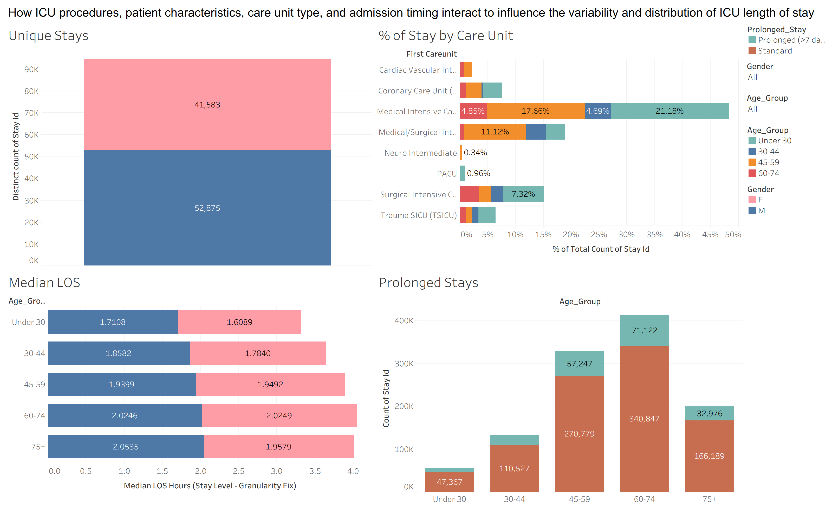

1. Unique ICU Stays
- Summary: Shows total ICU volume and how many stays are prolonged vs. standard.
- KPI Observation: Prolonged stays make up a smaller share of total stays, but still represent a significant portion of ICU utilization.

2. % of Stays by Care Unit
- Summary: Shows how ICU stays are distributed across units and which units carry more prolonged‑stay burden.
- KPI Observation: Medical and Surgical ICUs account for the largest share of stays, and these units also show higher proportions of prolonged stays.

3. Median LOS by Age & Gender
- Summary: Shows how median ICU length of stay increases with age and varies slightly by gender.
- KPI Observation: Median LOS rises steadily across age groups, indicating older patients generally require longer ICU care.

4. Prolonged Stays by Age Group
- Summary: Identifies which age groups contribute most to prolonged ICU stays.
- KPI Observation: Ages 45-74 contribute the highest volume of prolonged stays, making them the primary drivers of extended ICU resource use.

Dashboard 2: How do demographic characteristics vary across the ICU patient population?
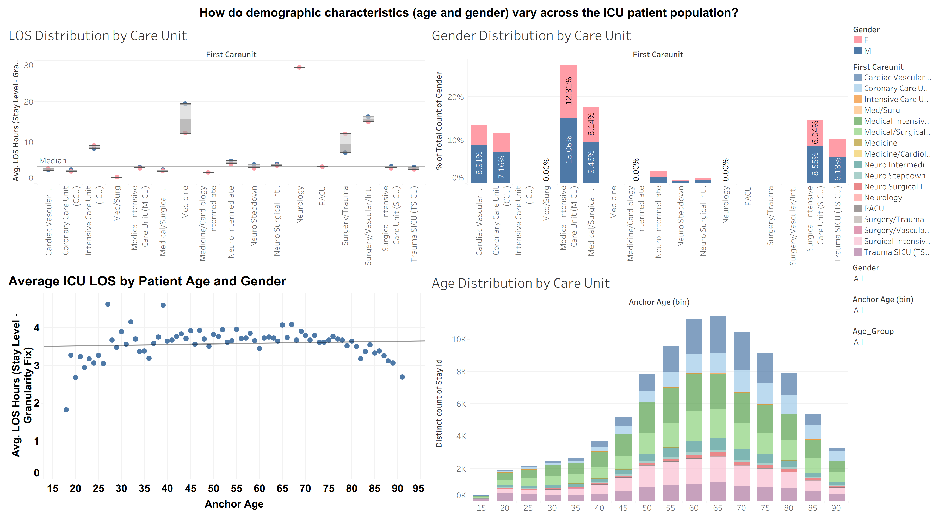
This dashboard examines how age, gender, and care-unit type shape ICU patient demographics and length-of-stay patterns. It highlights variation in LOS across units, demographic imbalances in certain ICUs, and how age influences both LOS and patient distribution.
1. LOS Distribution by Care Unit
- Summary: Compares average LOS across ICU units to show which units have longer or more variable stays.
- KPI Observation: Some units (e.g., Surgical/Trauma‑related ICUs) show higher median LOS, indicating heavier care intensity and resource demand.

2. Gender Distribution by Care Unit
- Summary: Shows the proportion of male vs. female patients in each ICU unit.
- KPI Observation: Most units have a slight male majority, suggesting gender‑skewed admission patterns across ICU types.

3. Average ICU LOS by Patient Age & Gender
- Summary: Plots how average LOS changes with age for male and female patients.
- KPI Observation: Average LOS increases steadily with age, showing that older patients typically require longer ICU care regardless of gender.

4. Age Distribution by Care Unit
- Summary: Shows how different age groups are distributed across ICU units.
- KPI Observation: Middle‑aged and older adults make up the largest share of ICU stays, especially in high‑acuity units.

Dashboard 3: Is ICU LOS influenced by admission timing, specifically time of day (day vs. night), day of week (weekday vs. weekend), and patient age?
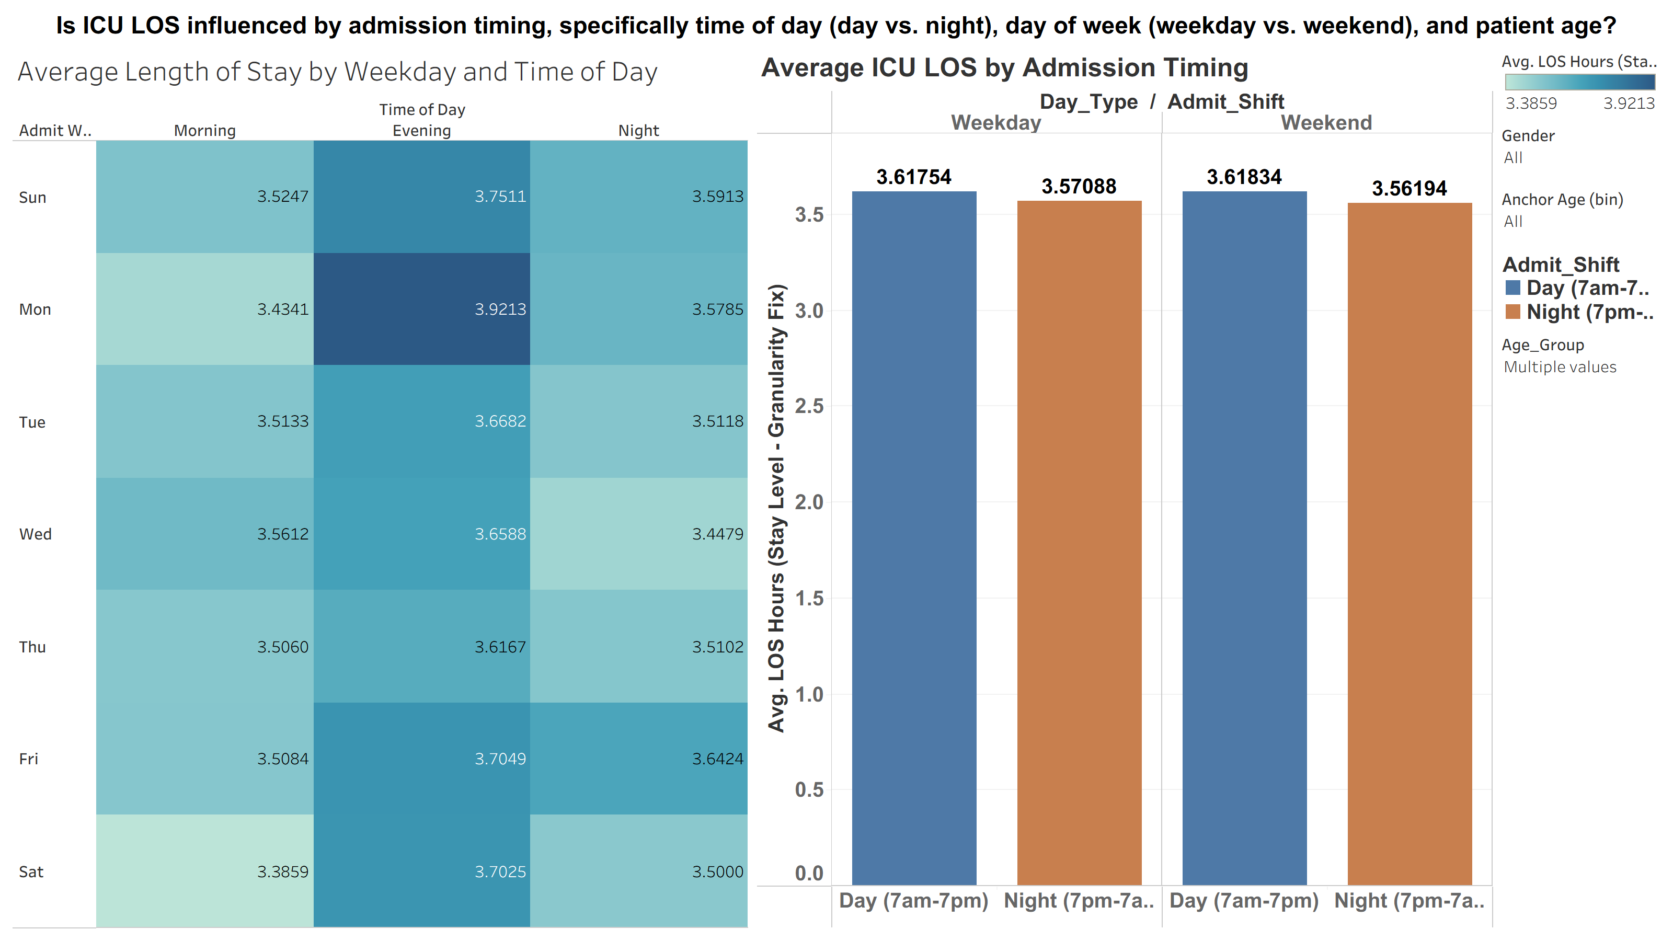
This dashboard analyzes how admission timing, time of day, and day of week affect ICU length of stay. It highlights subtle but consistent patterns showing that LOS varies slightly depending on when patients arrive, with evening admissions tending to have longer stays.

1. Average LOS by Weekday & Time of Day (Heatmap)
- Summary: Compares average LOS across combinations of weekday and admission shift (morning, evening, night).
- KPI Observation: Evening admissions consistently show the highest LOS across most days, suggesting later-day arrivals may require more complex or prolonged care.
2. Average ICU LOS by Admission Timing (Bar Chart)
- Summary: Aggregates LOS by weekday vs. weekend and day vs. night shift.
- KPI Observation: LOS is slightly higher for daytime admissions on both weekdays and weekends, though differences across all four categories are small, indicating timing effects are present but modest.

Dashboard 4: Which ICD-coded procedures are most frequently performed across different patient age groups?
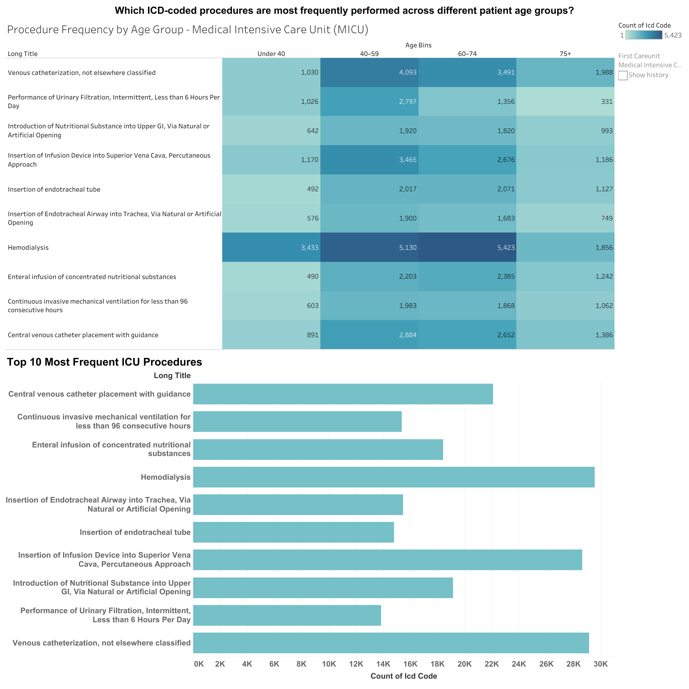
This dashboard highlights how procedure frequency varies by age group within the Medical ICU (MICU) (Other ICU units can be viewed as well) and identifies the most common interventions performed. It shows clear age-related patterns in treatment intensity, with certain procedures, especially hemodialysis, occurring far more frequently in older patients.
1. Procedure Frequency by Age Group (Heatmap)
- Summary: Shows how often each ICU procedure is performed across four age groups.
- KPI Observation: Hemodialysis is the most frequent procedure, especially among patients aged 60-74, indicating a high burden of renal support in older MICU populations.
2. Top 10 Most Frequent ICU Procedures (Bar Chart)
- Summary: Ranks the most common MICU procedures by total count.
- KPI Observation: Hemodialysis, central venous catheter placement, and infusion device insertions dominate overall procedure volume, reflecting core interventions required for critically ill patients.

Dashboard 5: Are specific ICU procedures are associated with prolonged LOS, and whether these associations differ across care unit types?
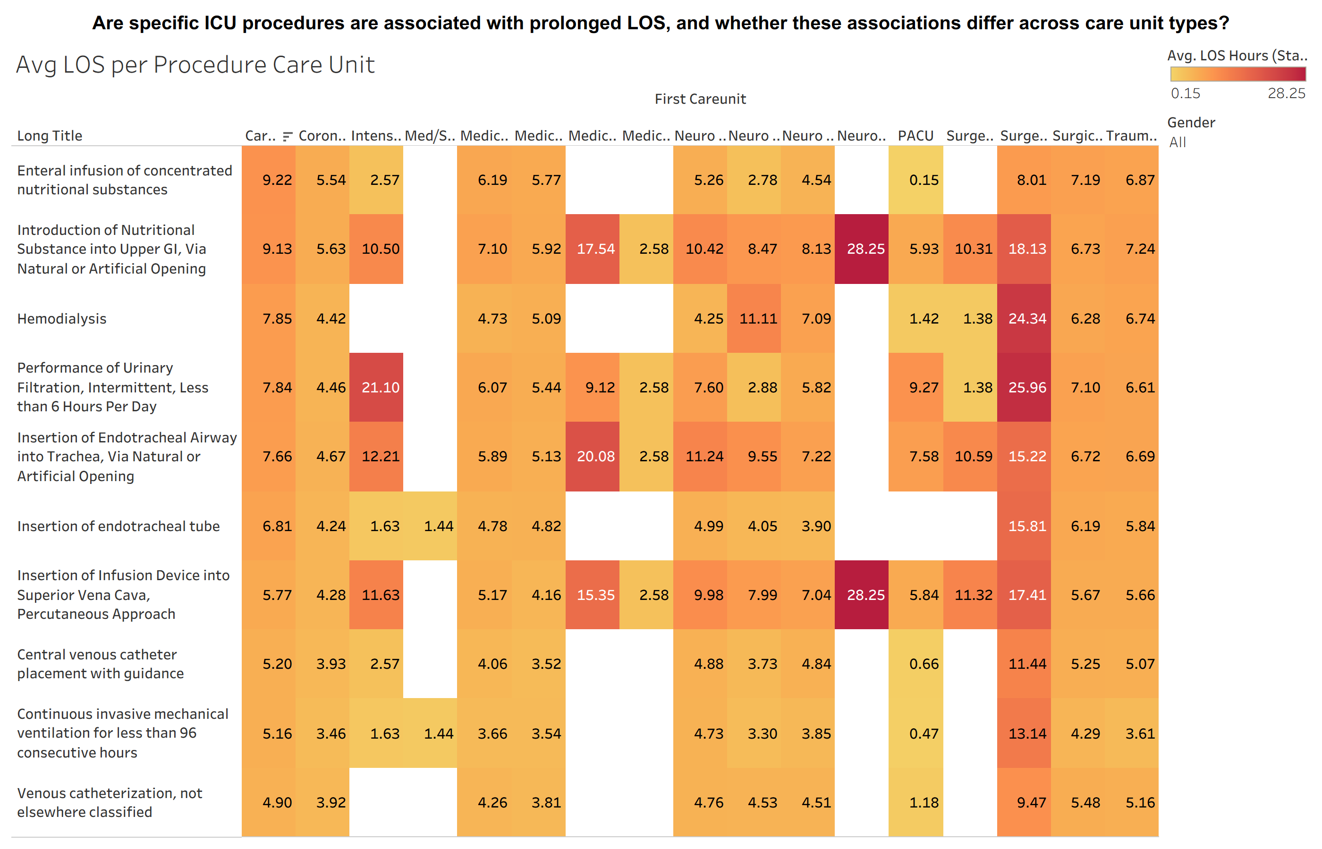
This dashboard examines how specific ICU procedures are associated with longer or shorter lengths of stay across different care units. It highlights which interventions tend to drive prolonged LOS and shows that the impact of a procedure varies significantly depending on the unit where it is performed.
1. Average LOS by Procedure × Care Unit (Heatmap)
- Summary: Compares average LOS for each procedure across all ICU care units to identify where procedures are linked to extended hospitalization.
- KPI Observation: Certain procedures, especially nutritional interventions, endotracheal airway insertions, and hemodialysis, show markedly higher LOS in specific units, indicating that both procedure type and care-unit context contribute to prolonged stays.

Dashboard 6: How do age, gender, and primary procedure categories jointly influence LOS across different care units?
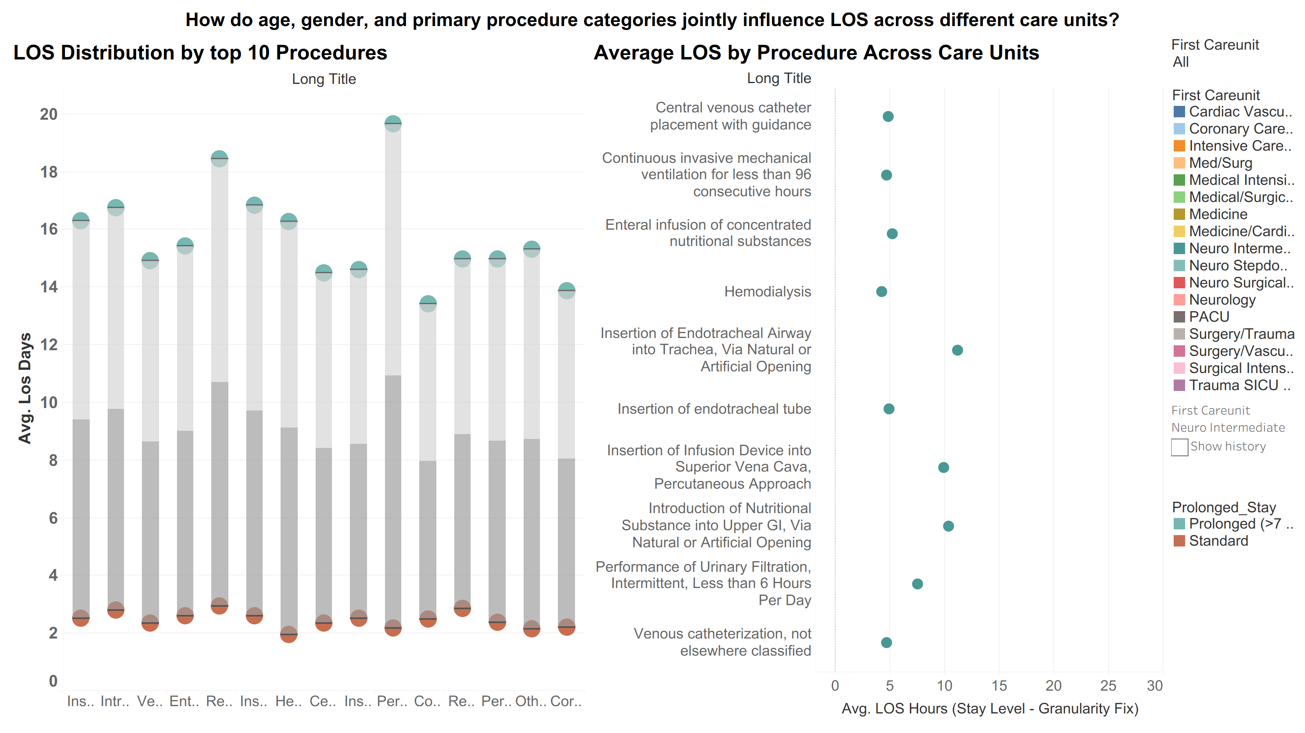
This dashboard examines how procedure type, care-unit context, and LOS category (standard vs. prolonged) jointly influence hospitalization duration. It highlights which procedures are most associated with extended stays and shows how LOS varies across care units for the same intervention.
1. LOS Distribution by Top Procedures (Bar Chart)
- Summary: Compares average LOS for the top procedures, split into standard vs. prolonged stays.
- KPI Observation: Prolonged stays consistently show much higher LOS across all procedures, indicating that procedure type alone doesn’t drive LOS, patient complexity and severity also play a major role.
2. Average LOS by Procedure Across Care Units (Dot Plot)
- Summary: Shows how the average LOS for each procedure varies across different ICU care units (Current: Neuro Intermediate).
- KPI Observation: Procedures such as nutritional interventions, airway insertions, and hemodialysis show the highest LOS across multiple units, suggesting these interventions are strong indicators of high-acuity, resource-intensive patients.

